Implement anomaly detection sample

Hasan Ahmed
hasan.ahmed@stud.fra-uas.de

Md Abdulla Al Mahamud Rosi
abdulla.rosi@stud.fra-uas.de

Abstract— A machine learning algorithm approach inspired by biology both structurally and functionally is called Hierarchical Temporal Memory (HTM) it's like the neocortex of a human brain. It employs a hierarchical arrangement of nodes to process time series data in a decentralized manner. According to each node and column, it can train to learn and recognize the patterns of the input data set. This capability enables the processing of information, recognition, and identification of patterns, and the making of future predictions based on previous learning. In this contemporary era, this process has been hugely used for anomaly detection and prediction in numerous sectors such as geological disasters, cyber-intrusion detection, military surveillance, system fault/damage detection. In our Project, we have implemented an anomaly detection sample using HTM, such that it learns multiple simple numeric integer sequences given to the HTM model as input and tries to learn patterns in it. After that, the model can detect anomalies within the predicted data according to the tolerance value which is given by the user. We also generate a graph which delineates anomalies.
Keywords—Anomaly Detection, HTM, Multisequence Learning, Neocortex API, Machine Learning.

Introduction
Numenta has developed Hierarchical Temporal Memory (HTM), a machine intelligence technology with biological constraints. The brain scientist Jeff Hawkins, the founder of the Redwood Neuroscience Research Institute and Sandra Blakeslee, published it in 2004 [1]. It is a Machine Learning approach based on Thousand Brains Theory. This technology operates according to a theory about how the biological neocortex works. Mammals only have one area of the brain called the neocortex, which is responsible for higher order processes like language, conscious movement and thought, and sensory perception [2]. We can think of HTM as a particular type of hierarchical Bayesian model. In order to learn the structure and invariance of the space of problems, it also makes use of spatial-temporal theory [3]. In recent years HTM has also been used for anomaly detection. Something that differs from the expected standard or normal state is called an anomaly. The terms outliers, discordant observations, exceptions, aberrations, surprises, etc. are frequently used to describe the anomalies. Finding anomalous patterns in data is known as anomaly detection. Anomaly detection has been extensively researched and used in many significant domains in recent years, including early warning systems for geological disasters, cyber-intrusion detection, military surveillance, and system fault/damage detection. As related fields develop, more applications in emerging industries like insurance, healthcare, and distributed sensor network surveillance begin to attract attention [4].
By identifying complex temporal patterns and relationships in data, HTM aims to mimic the fundamental workings of the neocortex and predict future events. This methodology excels in simulating sequential learning and related approaches like recurrent neural networks' (RNNs) Gated Recurrent Unit (GRU) and Long Short-Term Memory (LSTM).
A machine learning model called the Hierarchical Temporal Memory Cortical Learning Algorithm (HTM CLA) is intended to replicate the information processing processes of the neocortex in the human brain. Several essential elements are included in this algorithm to handle input data. An encoder first encodes the raw input data, converting it into a sparse distributed representation (SDR). After being run through a spatial pooler, this SDR, which contains information in binary format with few active bits, becomes more resilient to noise. After that, the output is processed by the Temporal Memory component, which oversees identifying and picking up patterns in the data. These acquired patterns are used by the Classifier component to categorize input data and forecast new patterns. Furthermore, the Homeostatic Plasticity Controller guarantees that the system continuously learns new patterns over time [5].

Methodology
To detect Anomalies in our project we used the Neocortex API, which was developed within the .NET framework, we also used Hierarchical Temporal Memory (HTM) for its functionality because of its best functionality. In our project testing and predictions are carried out through real numerical data where predicting folders contain data like training, but with added anomalies randomly added inside it. We are going to read data from both folders and train our HTM model using it. After that, we are going to take a part of the numerical sequence, trim it in the beginning, from all the numeric sequences of the predicting data and use it to predict anomalies in our data which we have placed earlier, and this will be automatically done, without user interaction.

Data Set 1:
For this project, we used two datasets from a weather dataset for Bangladesh. We took temperature of 20 days for different hours.
Below we give our data sequences where the sequences are in JSON files. We keep our dataset in two individual folders which are training_sequence (for training data where 4 files) and predicting_sequence (for predicting data were also 4 files). For example, an hourly sequence of weather temperature of a csv file within training folder.

Below, we provide insight into the structure and content of our data sequences, summarize within these JSON files. This systematic arrangement ensures clarity and accessibility throughout our analysis and model development efforts. Our JSON structure is like the data given below:
Listing 1 dataset 1
{
38, 40, 46, 29, 33, 27, 42, 47, 30, 31
46, 36, 39, 34, 43, 28, 32, 25, 45, 26
44, 36, 37, 41, 30, 47, 28, 33, 27, 42
37, 46, 26, 47, 44, 36, 29, 42, 38, 27
45, 47, 28, 35, 29, 37, 31, 40, 45, 25
}

Dataset 2:
We also use another kind of dataset as JSON files (which is fabricated) to predict anomaly detection, where the full process is like the above dataset, we did this to test our HTM process and the accuracy level test for various types of data. The fabricated dataset is based on the temperature of Bangladesh in the year 2025 [7]. Firstly, we keep both training and predicting datasets in output folder in the repository inside this folder, used datasets folders we can use the datasets when we need, we take them from these folders and insert the data into the training_files and predicting_files folders.
Here are also 4 files each file has 5 sequences where each sequence has 10 numerical data (means 10 days temperature value) for training, which is located in the training_sequence folder, and also 4 files each file has 5 sequences where each sequence has 10 numerical data (means 10 days temperature value) for predicting which is located in the predicting_sequence folder. We took a total of 20 days of data. Our Dataset structure is like the data given below:
Listing 2 dataset 2 (fabricated) structure
{
30, 18, 42, 19, 79, 20, 44, 16, 25, 17
19, 21, 3, 22, 41, 24, 39, 16, 34, 15
43, 32, 27, 35, 45, 30, 41, 23, 18, 31
42, 16, 30, 45, 22, 28, 56, 36, 39, 25
37, 42, 26, 24, 56, 41, 45, 28, 16, 32
}

HTM configuration:
The process starts with HTM Capturing Configuration and initializing the connection memory then executes the Spatial Pooler and Temporal Memory after that Spatial Pooler Memory is added to the cortex layer and trained for a maximum number of cycles. Since completing the full cycle of numbers, the trained cortex layer and the HTM classifier are returned.
The class requires the configuration settings for both the Encoder and HTM components to be passed to the next level. Then we will utilize the classifier object derived from the trained HTM to make predictions, aiding in anomaly detection.
Currently, we are in the process of preparing training and predicting datasets, which will encompass integer values ranging from 0 to 100. Importantly, these datasets lack any periodic patterns. To facilitate this task effectively, we are adhering to specific settings outlined in a provided listing.
In this configuration, we've chosen to express these integer values using 21 active bits. This decision aims to achieve a balance between precision and efficiency, considering that we're working with 101 distinct values ranging from 0 to 100.
To ensure our encoding scheme effectively covers the entire spectrum of integer values in this dataset, it's essential to compute the total number of input bits needed. This computation, designated as "n," involves adding the count of buckets (101, representing the integer values) to the width of the representation (21 for the active bits), then subtracting one. Thus, the calculation results in n = buckets + w – 1 = 101 + 21 – 1 = 121 [8].
By understanding and implementing these settings, we can effectively encode our data for subsequent training and predicting within our project, ensuring that the representation adequately captures the nuances of the dataset within the specified integer range.
Listing 3 Parameter values set for Encoder
int inputBits = 121;
int numColumns = 1210;
Dictionary<string, object> settings = new Dictionary<string, object>()
{
{ "W", 21},
{ "N", inputBits}
};

The lower and upper bounds of the data are configured to 0 and 100, respectively, under the assumption that all values will fall within this range. It is important to note that these bounds may need adjustment based on the specific input data being used. We have made some changes to HTM encoder’s parameters which is given in above code in Listing 3. We change this because of we faced various issues for this when we run the program it does not works properly and shows some error also then we testing through various values. At last we found these values 121 and 1210 for inputBits and numColumns respectively which works properly for our project [Listing 3].

Code Execution Process:
In our project, we have two types of datasets so first of all you have to decide which data you want to keep for execute this project. We keep training dataset as primary data inside the folder, “training_sequence”, and “predicting_sequence”, based on our project directory. To execute our project, clone the project first, then open the terminal write-dent run and press enter then the system asks for a tolerance value from you so give a tolerance value like 0.2 (20 %). Based on this tolerance value our system predicts anomalies for example: if the predicted value is more than 20% then the system declares anomalies.
At the beginning, we use the ExtractSequencesFromFolder method of the CsvSequenceFolder class to read all files inside a folder. These classes maintain a list of numerical sequences from the read data for repeated future use. To handle non-numeric data, exception handling is incorporated within certain classes. Additionally, the TrimSequences technique allows data trimming by removing one to four components (numbers 1 through 4) from the start, returning a numeric sequence [Listing 4].
Listing 4 Sequence Extraction and Trimming Utility for CSV Data

public List<List<double>> ExtractSequencesFromFolder()
{
....
return folderSequences;
}

public static List<List<double>> TrimSequences(List<List<double>> sequences)
{
....
return trimmedSequences;
}

Subsequently, the ConvertToHTMInput method of the CSVToHTMInputConverter class is employed to transform all the extracted sequences into a format compatible with Hierarchical Temporal Memory (HTM) training [Listing 5].
Listing 5 Sequence-to-Dictionary Mapping

Dictionary<string, List<double>> dictionary = new Dictionary<string, List<double>>();
for (int i = 0; i < sequences.Count; i++)
{
// Unique key created and added to dictionary for HTM Input
string key = "S" + (i + 1);
List<double> value = sequences[i];
dictionary.Add(key, value);
}
return dictionary;

After that, the ExecuteHTMModelTraining method of the HTMTrainingManager class is used to train the model using the converted sequences. The numerical data sequences from both the training (for learning) and predicting folders are combined before training the HTM engine. This class then returns the trained model object, which serves as the predictor [Listing 6].

Listing 6 HTM Prediction Initialization
.....
MultiSequenceLearning learning = new MultiSequenceLearning();
predictor = learning.Run(htmInput);
.....
.....
List<List<double>> combinedSequences = new List<List<double>>(sequences1);
combinedSequences.AddRange(sequences2);
.....

AIn the end, we use the HTMAnomalyExperiment class to detect anomalies in sequences read from files inside the predicting folder. All the previously explained classes—CSV file reading (using CsvSequenceFolder), combining and converting them for HTM training (using CSVToHTMInputConverter), and training the HTM engine (via HTMTrainingManager)—are utilized here. The same CsvSequenceFolder class is used to read files for predicting sequences. The TrimSequences method is then applied to trim sequences for anomaly testing, as explained earlier.fter that we use multisequencelearning classes for training our HTM model which is given below. Where we used the predictor object as a trained HTM model to predict anomalies from our extracted data from predicting_files [Listing 7].

Listing 7 Collecting Testing Data and Anomaly Detection

.....
allTestingData.Add(sequence.ToArray());
var (log, anomalies) = DetectAnomalyOnSequence(predictor, sequence.ToArray(), _tolerance);
experimentResults.AddRange(log);
allAnomalyIndices.Add(anomalies);
.....

The path to the training and predicting folders is set as the default and passed through the constructor, or it can be manually set within the class. [Listing 8].

Listing 8 Configuring CSV Folder Paths
In the end, the DetectAnomaly method is used to detect anomalies in our trimmed sequences one by one, utilizing the trained HTM model predictor [Listing 9].
.....
_trainingCSVFolderPath = Path.Combine(projectBaseDirectory, trainingFolderPath);
_predictingCSVFolderPath = Path.Combine(projectBaseDirectory, predictingFolderPath);
.....

Listing 9 Applying Anomaly Detection to Test Data

foreach (List<double> list in triminputtestseq)
{
.....
double[] lst = list.ToArray();
DetectAnomaly(myPredictor, lst);
}

Exception handling is implemented to manage errors thrown by the DetectAnomaly method, such as passing non-numeric values or when the number of elements in the list is less than two.
The DetectAnomaly method, which is the main method of the ExtractSequencesFromFolder class, detects anomalies in our data. It traverses each value in the list one by one in a sliding window manner, using the trained model predictor to predict the next element for comparison. An anomaly score is used to quantify the comparison, and if the prediction exceeds a certain tolerance level, it is flagged as an anomaly.
We can obtain our prediction in a list of results in the format of NeoCortexApi.Classifiers.ClassifierResult1[System.String]` from our trained model predictor using the following method [Listing 10].

Listing 10 Predictor to predict Anomalies
var res = predictor.Predict(item);

In our project, generally we get the output from the HTM is in the following format in our project, when we pass a numerical value 14 for example [Listing 11].

Listing 11 Output looks like given below
S3_11-5-12-10-14-13 - 100
S1_5-6-16-10-4-11-7 - 5
.....

The first line has the best prediction which the HTM model predicts, with accuracy. We can easily derive the predicted value, which will come after 14 (in this case, it is 13). The string operations are used to get these values. Later we are going to use this to determine anomalies [Listing 12].

Listing 12 Process of anomalies determination
if (i < sequence.Length - 1)
{
int nextIndex = i + 1;
double nextItem = sequence[nextIndex];
double predictedNextItem = double.Parse(tokens2.Last());

var anomalyScore = Math.Abs(predictedNextItem - nextItem);
var deviation = anomalyScore / nextItem;

if (deviation <= tolerance)
{
resultOutputLines.Add($"No anomaly detected in the next element. HTM Engine found similarity: {similarity}%.");
currentAccuracy += similarity;
}
else
{
resultOutputLines.Add($"****Anomaly detected**** in the next element. HTM Engine predicted: {predictedNextItem} with similarity: {similarity}%, actual value: {nextItem}.");
anomalousIndex.Add(i + 1);
i++; // Skip the anomalous element
resultOutputLines.Add("Skipping to the next element in the testing sequence.");
currentAccuracy += similarity;
}
}

We are using AnomalyScore, which is nothing, but the absolute value of the ratio of differences between HTM´s predicted number and actual number. If the ratio exceeds tolerance value, we mark it as an anomaly, otherwise, it is not. When an anomaly is detected, we skip that element in the list (we did not pass that value to HTM in the loop).

We use accuracyPerList to record accuracy per numerical sequence tested. record Accuracy is collected from inside each loop run, which indicates HTM model´s accuracy. We also add index positions of anomalies to anomalyIndices, when we encounter indices of anomalies in loop. total Accuracy and list Count is used to calculate average accuracy of the whole experiment.

After that we use static variables to access these from outside, i.e: in Program.cs [Listing 13].

Listing 13 Calculating Total Average Accuracy
StoredOutputValues.totalAvgAccuracy = _totalAccuracy / Math.Max(_iterationCount, 1);

The SequenceVisualizer class is used to plot graphs of sequences of data and their anomalies. This class used to showing the visual result for detecting anomalies compared to training sequences and the predicting sequence [Listing 14].
Listing 14 Plotting Learned vs. Testing Data
public static void CreateGraphForSequences(List<double[]> allLearnedData, List<double[]> allTestingData)
.....
allGraphs.Add(actualGraph);
allGraphs.Add(learnedGraph);
.....
var chart = Chart.Plot(allGraphs);
Unit Tests: We have developed a unit tests project to test different functionality of this anomaly project. While implementing the unit tests, we ensured the behavior of detection of anomalies in the project. Project files for the units test can be found here.

Results
Once the experiment concludes, the anomaly detection results persisted to the screen, along with HTM accuracy for each individual number sequences and overall HTM accuracy for the whole experiment. We have uploaded the anomaly results of our data in this repository for reference. output result of combined numerical sequence data from training folder (without anomalies) and predicting folder (with anomalies) can be found here.
Graphical view: We showed the graphical view of the training and predicting sequences along with anomalies. After successfully running the projects, we are generating the plots in html format in the browser as well as saving the files in the output graph folder. We generated 2 kinds of plots.
1. Training and predicting sequence plot

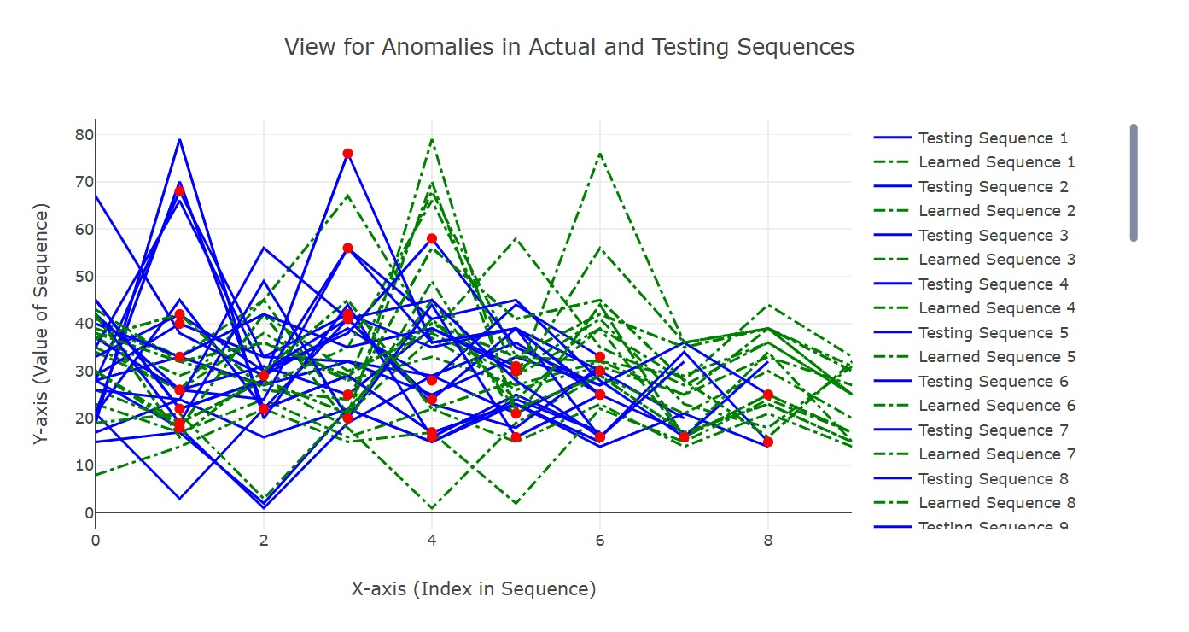
Figure 1: Comparison of Actual vs. Predicted Sequences

2. Training and predicting sequence with anomalies plot

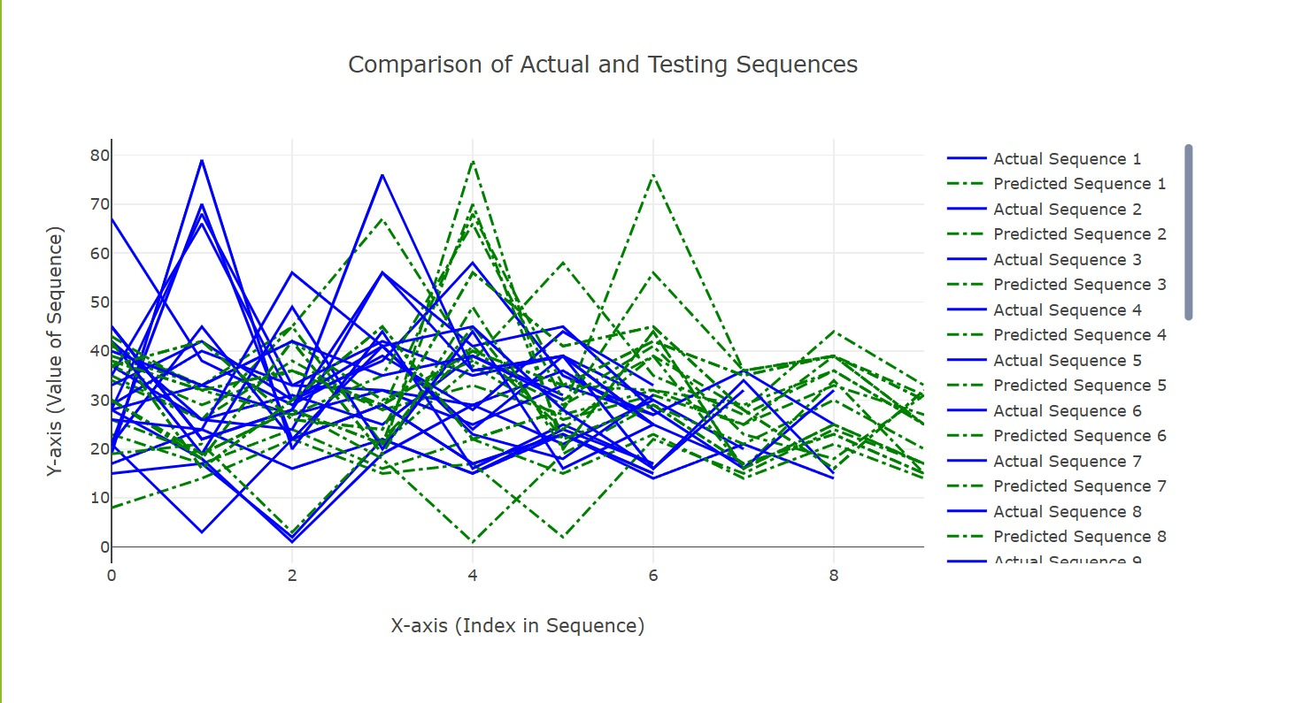
Figure 2: Anomaly Detection in Sequences

We found Anomaly detection results for Testing the sequence: 30, 18, 42, 19, 79, 20, 44, 16, 25, 17
FNR = FN / (FN + TP) = 0/ (0+2) = 0 FPR = FP / (FP + TN) = 2/ (2+5) = 0.29 Where, FN = 0, FP = 2, TN = 5, TP = 2.
After running our sample project, we analysed the output folder of this experiment and got the following average results:
Average FNR of the experiment: 0.22 • Average FPR of the experiment: 0.28
We can observe that the False Negative Rate(FNR) is in our output (0.22). It is desired that the false negative rate should be as lower as possible in an anomaly detection program. Lower false positive rate is also desirable, but not absolutely essential.
Although, it depends on a number of factors, like quantity (the more, the better) and quality of data, and hyperparameters used to tune and train model; more data should be used for training, and hyperparameters should be further tuned to find the most optimal setting for training to get the best results. We were using less number of numerical sequences as data to demonstrate our sample project due to time and computational constraints, but that can be improved if we use better resources, like cloud.

Conclusion
Accuracy rate represents the proportion of missed anomalies, where actual anomalies are incorrectly classified as normal. A lower accuracy rate is undesirable, particularly in critical applications like fraud detection. While a higher accuracy rate is generally preferred, it is not always essential, as excessive accuracy may lead to unnecessary investigations and wasted resources. An optimal balance is crucial for an effective anomaly detection model. Hierarchical Temporal Memory (HTM) is well-suited for real-time anomaly detection without requiring prior training and is also resilient to noise in input data.
Our experiment demonstrated varying accuracy levels, influenced by computational limitations. Testing was conducted on a local machine with a smaller dataset due to resource and time constraints. Utilizing more powerful computing resources, such as cloud platforms, can enhance performance. Additionally, increasing the dataset size and fine-tuning hyperparameters can further optimize the model’s accuracy.

References

- J. Hawkins and S. Blakeslee, “On Intelligence”, Henry Holt, New York, 2004.
- J. Struye and S. Latré, “Hierarchical temporal memory and recurrent neural networks for time series prediction: An empirical validation and reduction to multilayer perceptrons,” Neurocomputing, vol. 396, pp. 291–301, Jul. 2020, doi: https://doi.org/10.1016/j.neucom.2018.09.098.
- J. A. Starzyk, and H. He, “Spatio–Temporal Memories for Machine Learning: A Long-Term Memory Organization”, IEEE TRANSACTIONS ON NEURAL NETWORKS, vol. 20, no. 5, pp. 68-780, 2009.
- J. Wu, W. Zeng, and F. Yan, “Hierarchical Temporal Memory method for time-series-based anomaly detection,” Neurocomputing, vol. 273, pp. 535–546, Jan. 2018, doi: https://doi.org/10.1016/j.neucom.2017.08.026.
- “A Machine Learning Guide to HTM (Hierarchical Temporal Memory),” Numenta. https://www.numenta.com/blog/2019/10/24/machine-learning-guide-to-htm/, (Last Accessed: 22.03,2024).

